**DAILY ONLINE ACTIVITIES SUMMARY**

|  |  |  |  |  |  |
| --- | --- | --- | --- | --- | --- |
| **Date:** | | **17/06/2020** | **Name:** | **JASLINE SHARON TAURO** | |
| **Sem & Sec** | | **4th sem, A Section** | **USN:** | **4AL18CS029** | |
| **Online Test Summary** | | | | | |
| **Subject** | **---** | | | | |
| **Max. Marks** | **---** | | **Score** | **---** | |
| **Certification Course Summary** | | | | | |
| **Course** | | Application Developer | | | |
| **Certificate Provider** | | **AWS Educate** | **Duration** | | **3.30 hrs.** |
| **Coding Challenges** | | | | | |
| **Problem Statement:**   1. Write a C Program to Count numbers that don’t   contain 3**.** | | | | | |
| **Status: EXECUTED** | | | | | |
| **Uploaded the report in GitHub** | | | **YES** | | |
| **If yes Repository name** | | | <https://github.com/jaslinesharontauro/C_Prgms> | | |
| **Uploaded the report in slack** | | | **YES** | | |

Online Test Details: (Attach the snapshot and briefly write the report for the same)

Certification Course Details: (Attach the snapshot and briefly write the report for the same)

Coding Challenges Details: (Attach the snapshot and briefly write the report for the same)

CERTIFICATION COURSE DETAILS:

Today I have continued the course “Application Developer” by AWS Educate. In this course today I learnt about ‘Data and Databases: Structures, Relational and Non-Relational’. In this module I learnt about Data Structures and their functionalities. I have also completed this module by clearing the assessment.



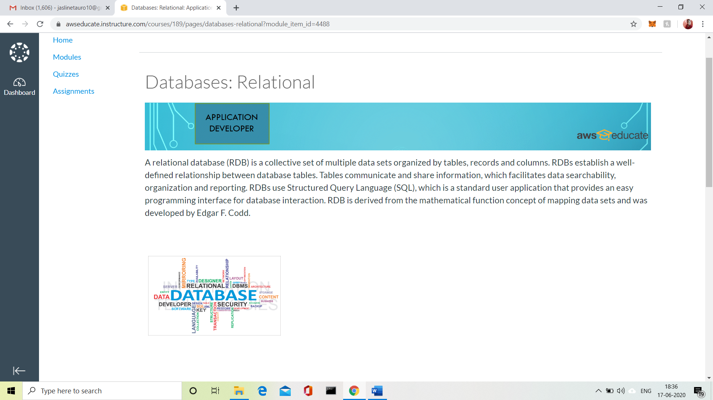

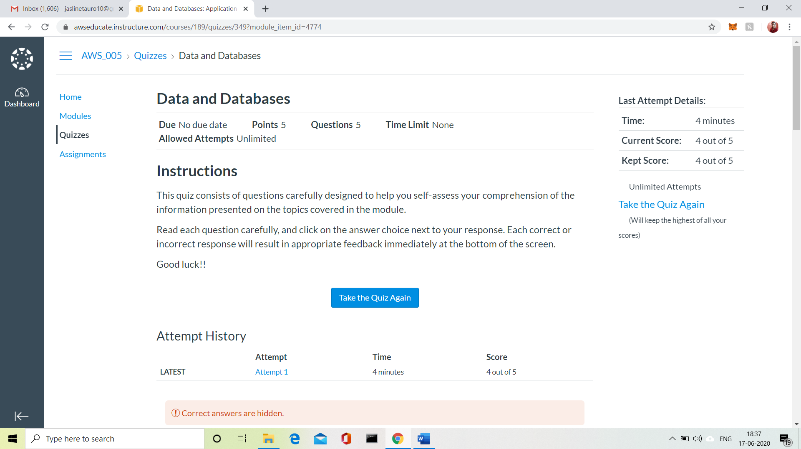

3.CODING CHALLENGES:

Problem Statement 1:

Write a C Program to Count numbers that don’t contain 3.

Given a number n, write a function that returns count of numbers from 1 to n that don’t contain digit 3 in their decimal representation.  
**Examples:**  
**Input:** n = 10  
**Output:** 9  
Here input is 10 means the numbers within 10 are 1,2,3,4,5,6,7,8,9,10 in this series 3 occurs only 1 times so answer is 9

**More examples**  
Input: n = 45  
Output: 31  
// Numbers 3, 13, 23, 30, 31, 32, 33, 34,  
// 35, 36, 37, 38, 39, 43 contain digit 3.

Input: n = 578  
Output: 385

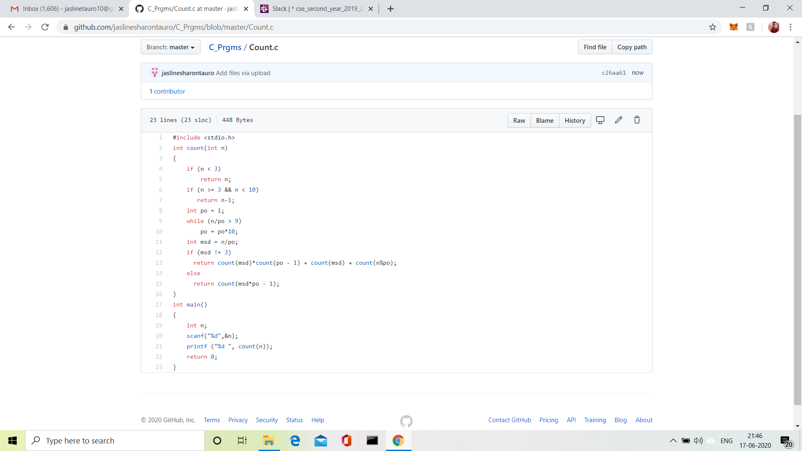

Solution uploaded in GitHub.